# Johnson DAD 220 Module Four Major Activity Database Documentation Template

Complete these steps as you work through the directions for this activity. Replace the bracketed text with your screenshots and brief explanations of the work they capture. Each screenshot and its explanation should be sized to approximately one quarter of the page, with the description written below the screenshot. Follow these rules for each of the prompts and questions below. Review the example document for assistance.

**Follow Steps 1 through 4 from the Module Three Major Activity *only* to generate tables for this assignment.**

1. Import the data from each file into tables.
   1. Use the import utility of your database program to load the data from each file into the table of the same name. You’ll perform this step three times, once for each table.
   2. Provide the SQL commands you ran against MySQL to complete this successfully in your answer.

* 1. After entering the commands: **mysql, USE QuantigrationRMA;,** and **show tables;,** to use the database, load the database to the RMA file and display the current tables respectively, I used the following commands to import data into the customers, orders, and RMA tables: **LOAD DATA INFILE '/home/codio/workspace/customers.csv'**

**INTO TABLE Customers**

**FIELDS TERMINATED BY ','**

**LINES TERMINATED BY '\r\n';**

**LOAD DATA INFILE '/home/codio/workspace/orders.csv'**

**INTO TABLE Orders**

**FIELDS TERMINATED BY ','**

**LINES TERMINATED BY '\r\n';**

**LOAD DATA INFILE '/home/codio/workspace/rma.csv'**

**INTO TABLE RMA**

**FIELDS TERMINATED BY ','**

**LINES TERMINATED BY '\r\n';**

1. Write basic queries against imported tables to organize and analyze targeted data.

For each query, include a screenshot of the query and its output. You should also include a 1- to 3-sentence description of the output.

* 1. Write an SQL query that returns the count of orders for customers located only in the city of Framingham, Massachusetts.
     1. How many records were returned?

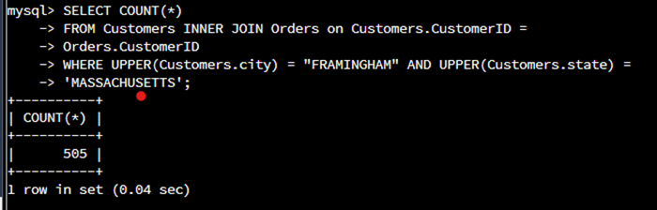

The following commands were used to determine how many records were returned. Using COUNT, FROM, and WHERE with an inner join between customers and orders were appropriate for this outcome of 505 records. **SELECT COUNT(*)**

**FROM Customers INNER JOIN Orders on Customers.CustomerID =**

**Orders.CustomerID**

**WHERE UPPER(Customers.city) = "FRAMINGHAM" AND UPPER(Customers.state) =**

**'MASSACHUSETTS';**

* 1. Write an SQL query to select all of the customers located in the state of Massachusetts.
     1. Use a WHERE clause to limit the number of records in the Customers table to only those that are located in Massachusetts.
     2. Record an answer to the following question: How many records were returned?

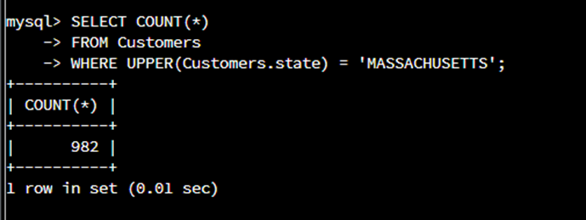

For this screenshot, I was able to use the following commands to determine the returned record number of 982. **SELECT COUNT(*)**

**FROM Customers**

**WHERE UPPER(Customers.state) = 'MASSACHUSETTS';**

* 1. Write an SQL query to insert four new records into the Orders and Customers tables using the following data:
     1. Customers Table

| **CustomerID** | **FirstName** | **Lastname** | **StreetAddress** | **City** | **State** | **ZipCode** | **Telephone** |
| --- | --- | --- | --- | --- | --- | --- | --- |
| 100004 | Luke | Skywalker | 17 Maiden Lane | New York | NY | 10222 | 212-555-1234 |
| 100005 | Winston | Smith | 128 Sycamore Street | Greensboro | NC | 27401 | 919-555-6623 |
| 100006 | MaryAnne | Jenkins | 2 Coconut Way | Jupiter | FL | 33458 | 321-555-8907 |
| 100007 | Janet | Williams | 58 Redondo Beach Blvd | Torrence | CA | 90501 | 310-555-5678 |

This screenshot’s outcome was a bit tricky because the attribute of Street was not the same as StreetAddress which is given on the table above the screenshot. To find the correct attribute, I had to describe customers;, then enter: **INSERT INTO Customers (CustomerID, FirstName, LastName, Street, City, State, ZipCode, Telephone)**

**VALUES**

**(100004, 'Luke', 'Skywalker', '17 Maiden Lane', 'New York', 'NY', 10222, 2125551234),**

**(100005, 'Winston', 'Smith', '128 Sycamore Street', 'Greensboro', 'NC', 27401, 9195556623),**

**(100006, ' MaryAnne', 'Jenkins', '2 Coconut Way', 'Jupiter', 'FL', 33458, 3215558907),**

**(100007, 'Janet', 'Williams', '58 Redondo Beach Blvd', 'Torrence', 'CA', 90501, 3105555678);**

* + 1. Orders Table

| **OrderID** | **CustomerID** | **SKU** | **Description** |
| --- | --- | --- | --- |
| 1204305 | 100004 | ADV-24-10C | Advanced Switch 10GigE Copper 24 port |
| 1204306 | 100005 | ADV-48-10F | Advanced Switch 10 GigE Copper/Fiber 44 port copper 4 port fiber |
| 1204307 | 100006 | ENT-24-10F | Enterprise Switch 10GigE SFP+ 24 Port |
| 1204308 | 100007 | ENT-48-10F | Enterprise Switch 10GigE SFP+ 48 port |

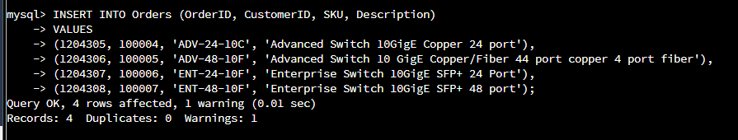

While there was a warning to the outcome of this command, I was able to add the orders, customerid’s, SKU’S, and descriptions. **INSERT INTO Orders (OrderID, CustomerID, SKU, Description)**

**VALUES**

**(1204305, 100004, 'ADV-24-10C', 'Advanced Switch 10GigE Copper 24 port'),**

**(1204306, 100005, 'ADV-48-10F', 'Advanced Switch 10 GigE Copper/Fiber 44 port copper 4 port fiber'),**

**(1204307, 100006, 'ENT-24-10F', 'Enterprise Switch 10GigE SFP+ 24 Port'),**

**(1204308, 100007, 'ENT-48-10F', 'Enterprise Switch 10GigE SFP+ 48 port');**

* 1. In the Customers table, perform a query to count all records where the city is Woonsocket, Rhode Island.
     1. How many records are in the customers table where the field “city” equals “Woonsocket”?

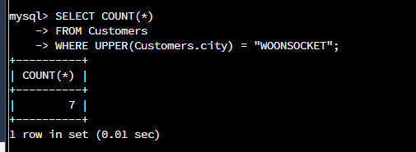

In this screenshot, I was able to determine the number of records as 7 with the following command. **SELECT COUNT(*)**

**FROM Customers**

**WHERE UPPER(Customers.city) = "WOONSOCKET";**

* 1. In the RMA database, update a customer’s records.
     1. Write an SQL statement to select the current fields of **status** and **step** for the record in the **rma**table with an **orderid**value of “5175.”
        1. What are the current status and step?

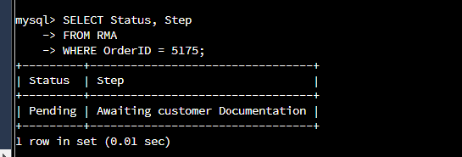

The outcome in this screenshot is pending status and the step of awaiting customer documentation with the command: **SELECT Status, Step**

**FROM RMA**

**WHERE OrderID = 5175;**

* + 1. Write an SQL statement to update the**status** and **step**for the **OrderID**, 5175 to **status**= “Complete” and **step**= “Credit Customer Account.”
       1. What are the updated **status**and **step**values for this record? Provide a screenshot of your work.

The command: **UPDATE RMA**

**SET Status = "Complete", Step = "Credit Customer Account"**

**WHERE OrderID = 5175;** was used to update the RMA with the status complete and step as credit customer account.

* 1. Delete RMA records.
     1. Write an SQL statement to delete all records with a reason of “Rejected.”
        1. How many records were deleted? Provide a screenshot of your work.

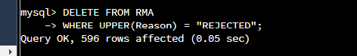

In this screenshot, 596 records are displayed as deleted from the RMA file with the command: DELETE **FROM RMA**

**WHERE UPPER(Reason) = "REJECTED";**

1. Create an output file of the required query results.

Write an SQL statement to list the contents of the orders table and send the output to a file with a .csv extension.

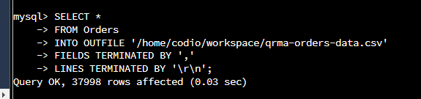

With the following command: **SELECT \***

**FROM Orders**

**INTO OUTFILE '/home/codio/workspace/qrma-orders-data.csv'**

**FIELDS TERMINATED BY ','**

**LINES TERMINATED BY '\r\n';**,I was able to list the contents of the orders table and send the output to a file with a .csv extension.